LAB 11 TASKS
- Create a class Person with variables name and age and a function display() to print them.
Create a derived class Student that adds a variable rollNumber and a function showRoll() to print it.
Task: Create a Student object, set all values, and call both functions.
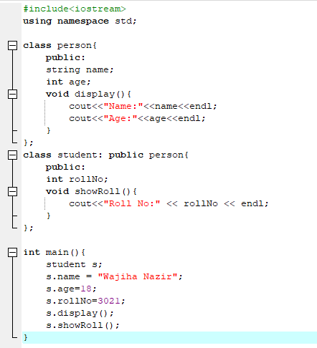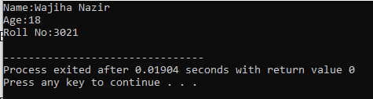
- Create a class Employee with a function work() that prints "Employee is working".
Create a derived class Manager that overrides work() to print "Manager is managing work".
Task: Create a Manager object and call the work() function to see runtime polymorphism.
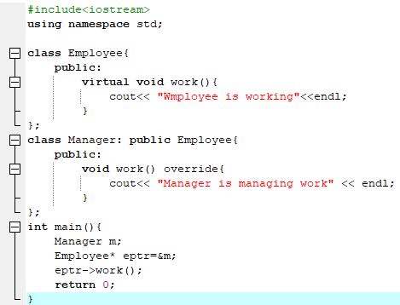
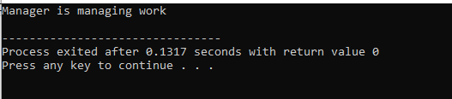
- Create a class Printer with a function print(int x) that prints an integer and a function print(double y) that prints a double.
Task: Create a Printer object and call both print() functions to show compile-time polymorphism.
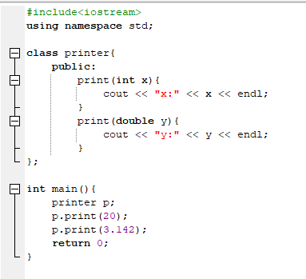
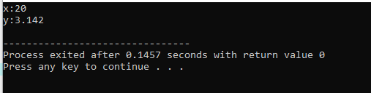
- Create a class BankAccount with a variable balance and a function deposit() to add money.
Create a derived class SavingsAccount that adds a function interest() to calculate 5% interest on balance.
Task: Create a SavingsAccount object, deposit some money, and display balance and interest.
